**WEEK - 2 : Advanced SQL (Part 1)**

**Exercise 1: Ranking and Window Functions**

**SQL Queries:**

-- ROW_NUMBER

SELECT EmpID, EmpName, Department, Salary,

ROW_NUMBER() OVER (PARTITION BY Department ORDER BY Salary DESC) AS RowNum

FROM Employees;

-- RANK

SELECT EmpID, EmpName, Department, Salary,

RANK() OVER (PARTITION BY Department ORDER BY Salary DESC) AS RankPos

FROM Employees;

-- DENSE_RANK

SELECT EmpID, EmpName, Department, Salary,

DENSE_RANK() OVER (PARTITION BY Department ORDER BY Salary DESC) AS DenseRankPos

FROM Employees;

**Outputs:**

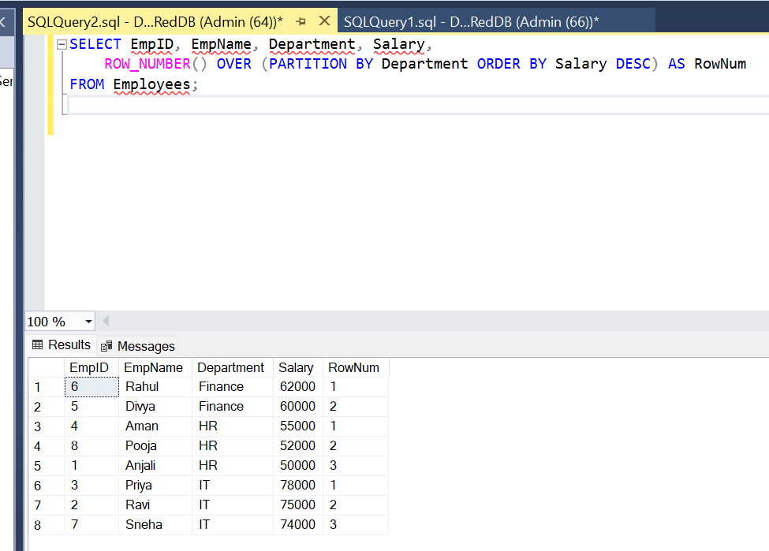

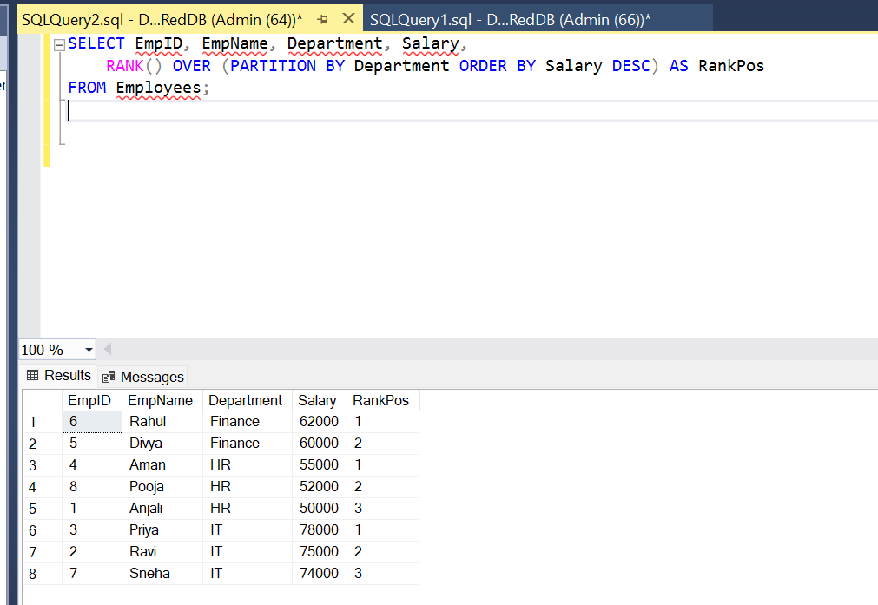

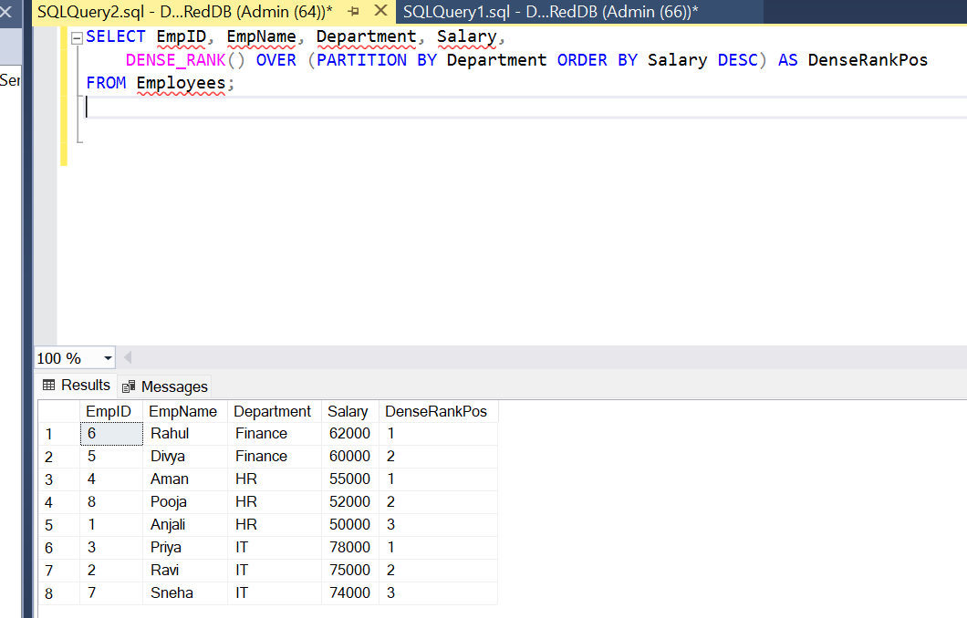

**Exercise 2: Index**

**SQL Queries:**

-- Create Index on Salary

CREATE NONCLUSTERED INDEX idx_salary ON Employees(Salary);

-- Query using Indexed Column

SELECT * FROM Employees WHERE Salary > 60000;

**Output:**

